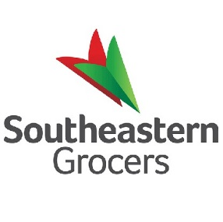

Product & Important Updates Form

|  |  |  |  |
| --- | --- | --- | --- |
| * This form must be completed for all product and important updates * Send completed form to your Merch Ops partner   **ӿ**= required information | | | |
| **ӿ** Banner(s) – check all applicable | BI-LO Fresco y Más Harveys Winn-Dixie | | |
| **ӿ** Select Department | Choose an item. | | |
| **ӿ** Summarized title |  | | |
| **ӿ** Stores/DC(s) affected  (“All” or list specific DC or store group/area. If specific store list, attach stores in excel format) |  | | |
| **ӿ** Date to publish communication: | Click here to enter a date. | **ӿ** Expire Date of comm: | Click here to enter a date. |

|  |
| --- |
| **Enter communication below. Please use table if needed to communicate multiple items as shown, entering in more columns as needed to the right** |
| |  |  | | --- | --- | | **Code** | **Item** | |  |  | |  |  | |  |  | |  |  | |